Coursera

IBM Data Science Specialization

**Final Capstone Project Report**

|  |  |  |
| --- | --- | --- |
|  | OR |  |

|  |
| --- |
| **Berlin or Munich? - Clustering the Neighborhoods of Berlin and Munich** |

|  |  |
| --- | --- |
| **Submitted by** | Rekha Remadevi |
| **Submission date** | 08.03.2021 |
| **Course of Study** | IBM Data Science Professional Certificate. |

# Introduction

It is quite difficult to find two more dramatically contrasting cities within the same country than Berlin and Munich.

Munich and Berlin are two of the best cities in Germany, and both have a lot to offer. Berlin is not only Germany’s capital and largest city; it is also the cultural hub of the nation. One of the most fascinating cities in Europe, Berlin is vibrant and edgy and is Germany’s centre for fashion, art and culture. Berlin’s nightlife is famously impressive, known as the techno capital of the world. Berlin is a city of culinary delight offering a wide variety of food ranging from traditional German food to American burgers, at an affordable price.

Munich is the wealthy capital of Bavaria and the gateway to the Alps. It is said to be one of the most beautiful and charming cities in all of Germany and is filled with museums and beautiful architecture. It is most famous for being the centre of Oktoberfest festivities, which attracts over 6 million visitors every year.

# Business Problem

A person wants to relocate to Germany, and he is considering moving and buying an apartment within the neighborhoods of Berlin or Munich. In order to make a decision, he aims to obtain some information about the neighborhoods/ districts in Berlin and Munich. This information also helps tourists to choose their destinations depending on the experiences that the neighborhoods have to offer and what they would like to experience. This study will help stakeholders make informed decisions and address any concerns they have including the different kinds of cuisines, provision stores and what the city has to offer.

# Data Description

In terms of data, it is of paramount importance to obtain geographical location data for both Berlin and Munich. Postal codes in each city serve as a starting point. Using Postal codes, one can find out the neighborhoods, boroughs, venues and their most popular venue categories.

## Berlin

To derive our solution, We scrape our data from  <http://www.places-in-germany.com/14356-places-within-a-radius-of-15km-around-berlin.html>

This [www.Places-in-Germany.com](http://www.Places-in-Germany.com) page has information about some states in Germany

1. Borough: Name of Neighbourhood
2. Zip code: Postal codes for Belin

The data will be scraped with a tool called *Beautiful Soup* and directly transformed to *Pandas* and *Data Frame*. It needs some cleaning while gathering only the boroughs of the city.

## Munich

The postal code and district names of all districts in Munich are required to solve the task. The data published at <https://www.muenchen.de/int/en/living/postal-codes.html> is used in order to fetch the necessary data. The data is fetched by using the *pandas library* and the built-in *pd. read HTML ()* function. This function scrapes the data available on the website and stores all tables in data frames.

1. District: Districts name
2. Postal Code: Postal code for Districts in Munich

## Geodata

The *python geopy* library is used for getting the latitude and longitude values. This library only requires the name of a neighborhood and accepts also a postal code and returns the latitude and longitude values for the given address.

## Venue data

As a next step, the available top 100 venues shall be fetched for each postal code. For this task, an *API call* to the *Foursquare API* is performed.  *Foursquare* is a location data provider with information about all manner of venues and events within an area of interest. Such information includes venue names, locations, menus and even photos. As such, the foursquare location platform will be used as the sole data source since all the stated required information can be obtained through the API.

Based on all the information collected for both Berlin and Munich, we have sufficient data to build our model. We cluster the neighborhoods together based on similar venue categories followed by a presentation of the observations and findings. Using this data, one can take the necessary decision.

# Methodology

By using *Python libraries*, we will be creating our model. The required packages are the following:

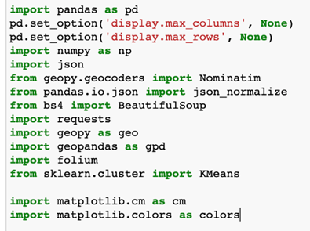

## Data Collection

To collect data for Berlin, We scrape our data from  <http://www.places-in-germany.com/14356-places-within-a-radius-of-15km-around-berlin.html> using the following code:

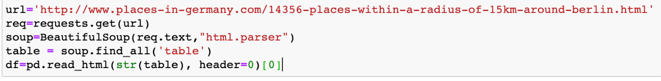

The data look like this

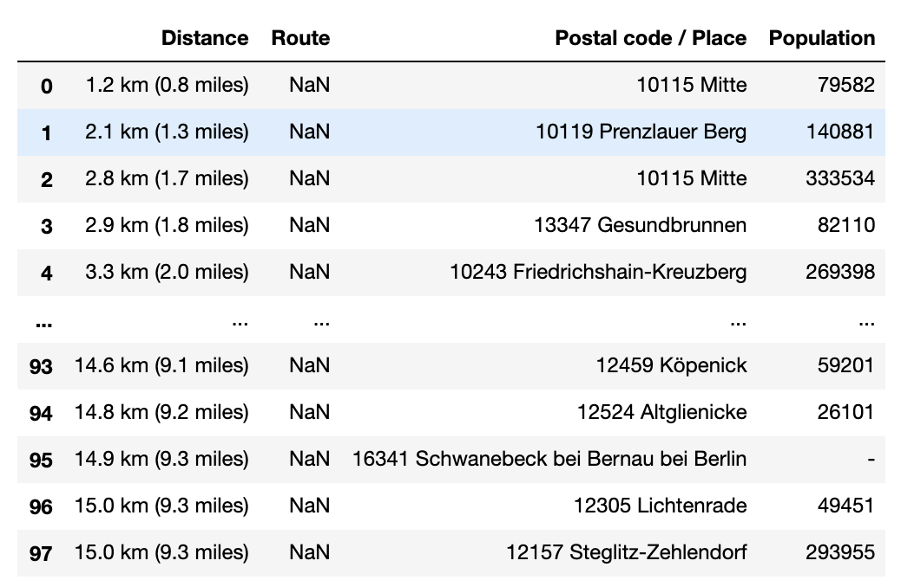

**Figure 4‑1 – Overview of Postal codes in the neighborhoods of Berlin.**

By using the page <https://www.muenchen.de/int/en/living/postal-codes.html>, Munich data has been collected. The data is fetched by using the *pandas library* and the built-in *pd. read HTML ()* function. This function scrapes the data available on the website and stores all tables in data frames. The following codes has been used for this.

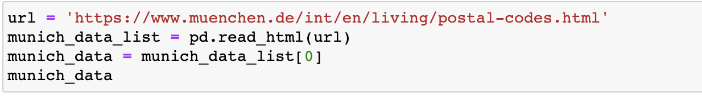

The extracted data look like this

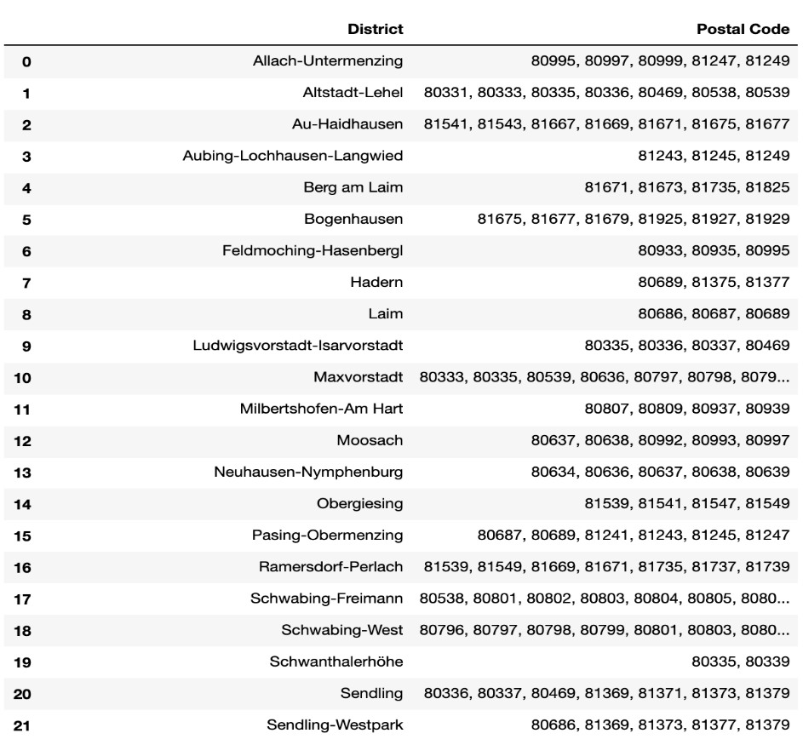

**Figure 4‑2 – Overview of Postal codes and Districts names in Munich.**

## Data preprocessing

We split all the places according to boroughs for Berlin

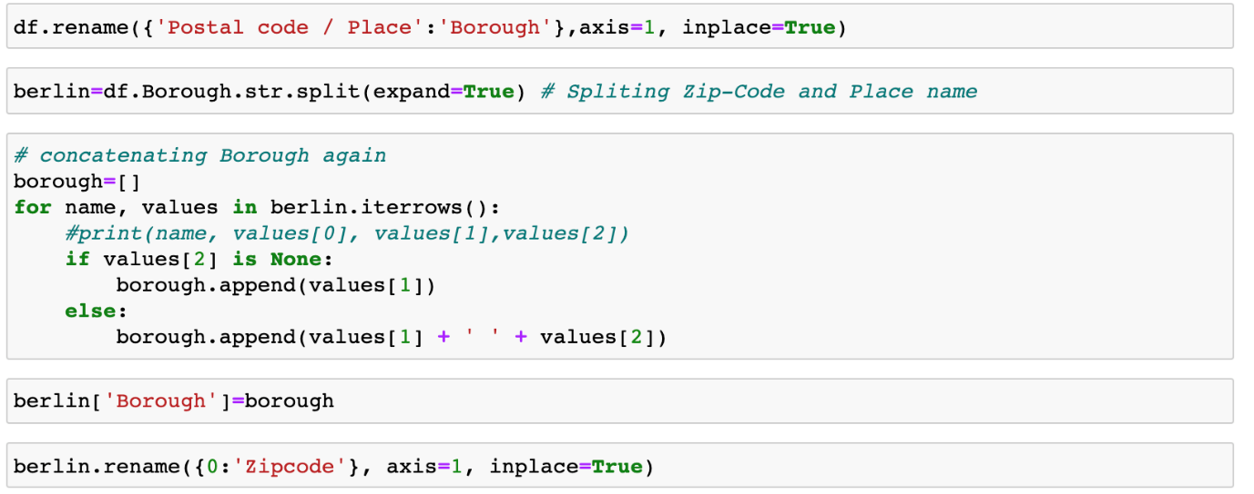

We split all the places according to their postal codes for Munich

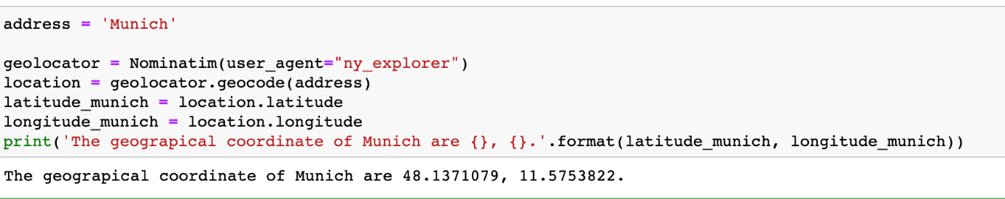

## Feature Selection

For both the datasets, only the borough, neighbourhood, postal codes and geolocations (latitude and longitude) are needed.

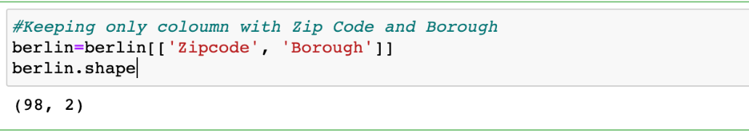

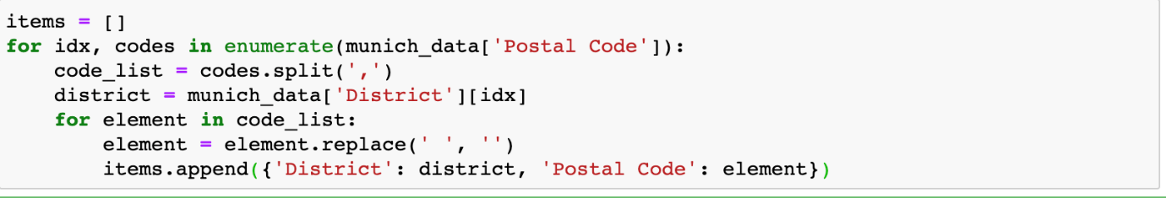

## Visualizing the Neighborhoods of Berlin and Munich

Using the *Folium package*, it is possible to visualize the maps of Berlin and Munich with the neighbourhoods.

Neighbourhood Map of Berlin:

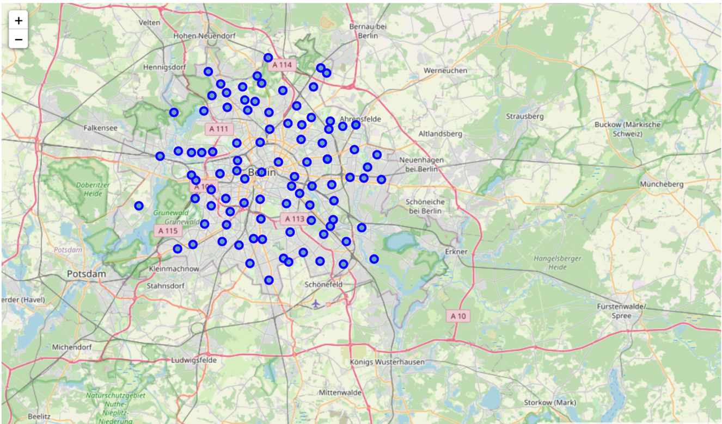

**Figure 4‑3 - Overview Berlin Boroughs**

Neighbourhood Map of Munich:

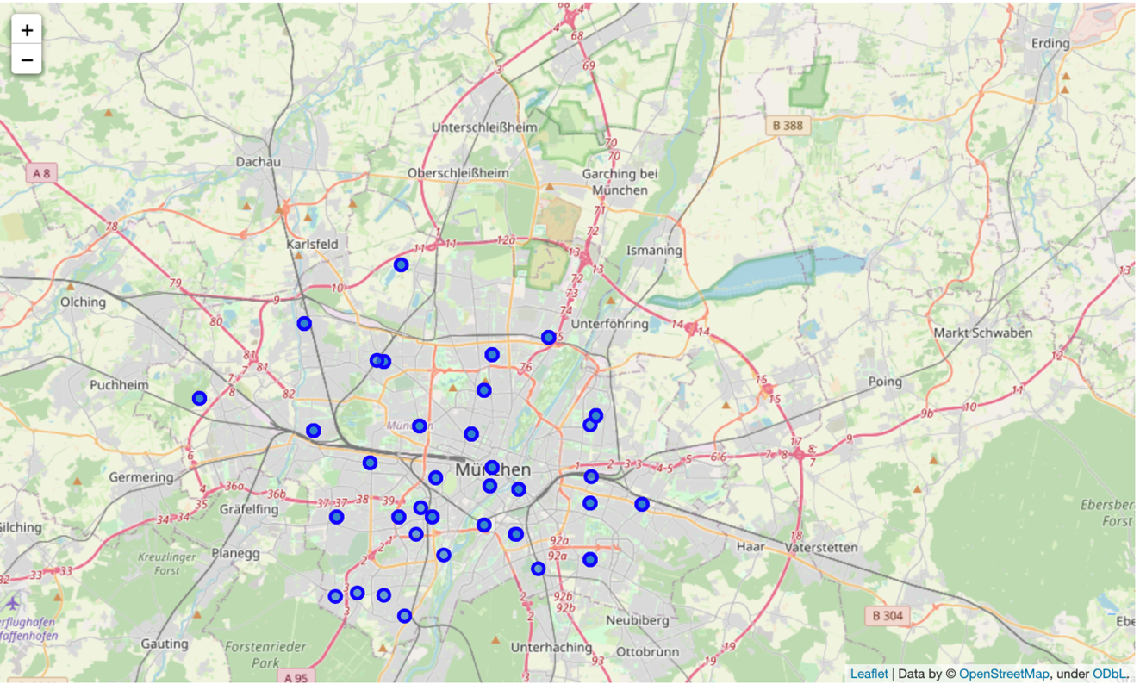

**Figure 4‑4 - Figure 4: District wise map of Munich**

Visualization of the neighbourhoods is available now and with the help of *Foursquare API,* it is easy to collect information pertaining to each neighbourhood including that of the name of the neighbourhood, geo-coordinates, venue and venue categories within a 500m radius of each neighborhood

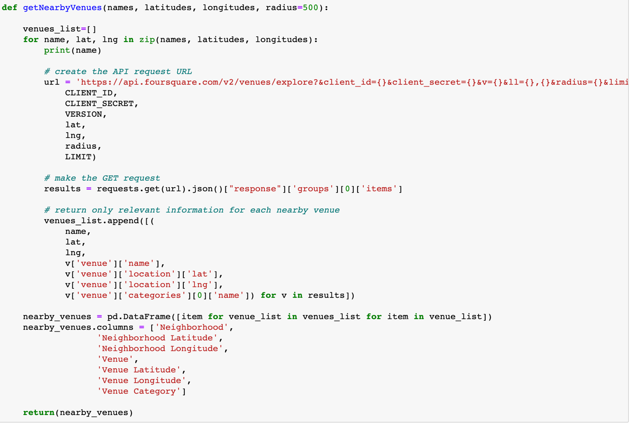

Resulting data look like this

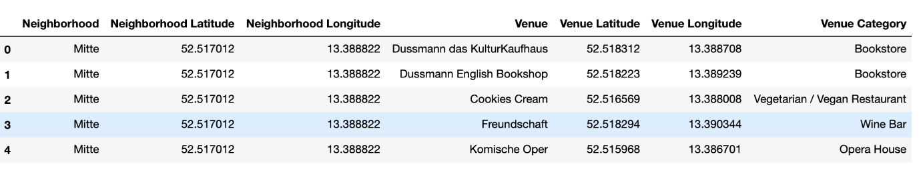

**Figure 4‑5 - Overview of Latitude and Longitude in Berlin**

## One Hot Coding

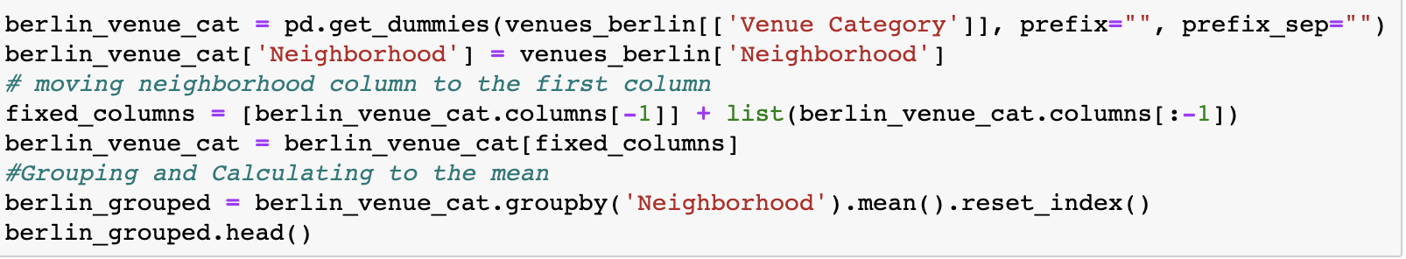One Hot Encoding is a process by which categorical variables are converted into a form that could be provided to ML algorithms to do a better job in prediction. Since we are trying to find out what are the different kinds of venue categories present in each neighbourhood and then calculate the top 10 common venues to base our similarity on, we use the One Hot Encoding to work with our categorical datatype of the venue categories.

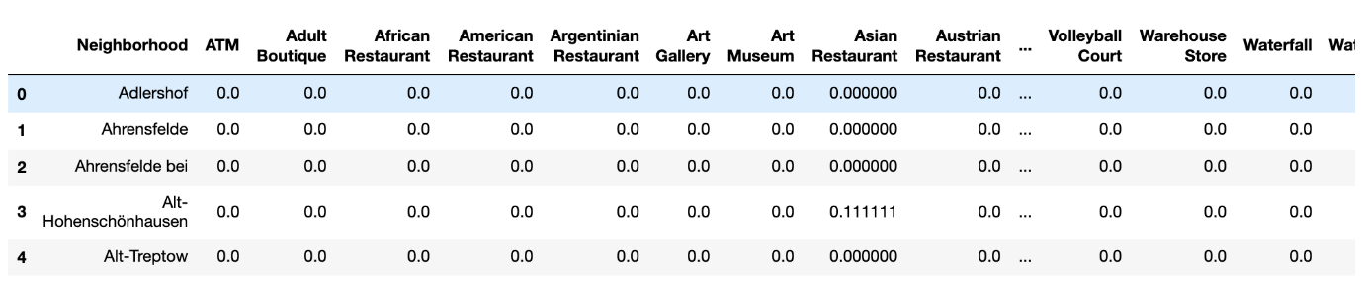

**Figure 4‑6 - Overview of venues in Berlin.**

## Top Venues in the Neighbourhoods

In this step, we will rank and label top venue categories in the neighbourhoods of Berlin and Munich.

Let's make a function to get the topmost common venue categories

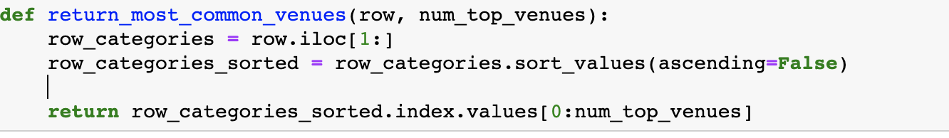

There are many categories, we will consider top 15 categories to avoid data skew.

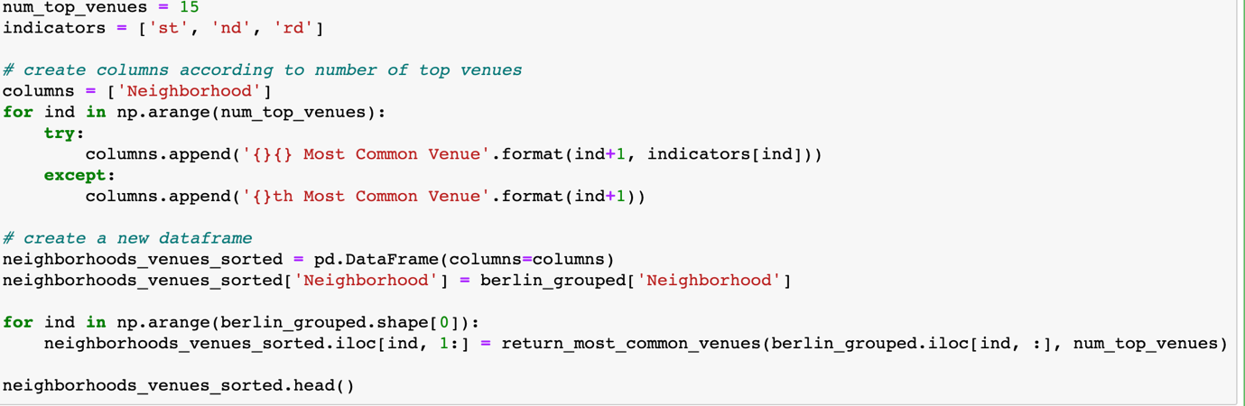

## Model Building- K means

By using *KMeans Clustering* Machine learning algorithm to cluster similar neighbourhoods together, we will be going with the number of clusters as 5.

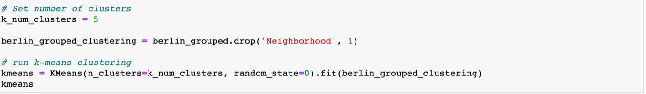

Join Berlin grouped with combined data on neighbourhood to add latitude & longitude for each neighbourhood to prepare it for plotting.

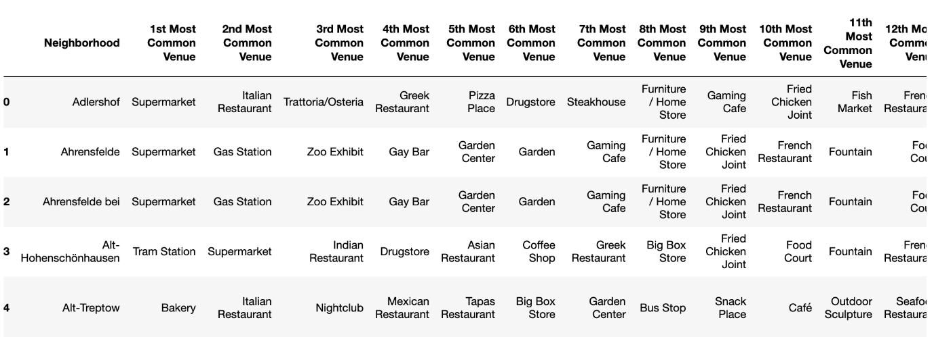

**Figure 4‑7 - Overview of top 15 venues in Berlin**

## Visualizing the clustered Neighbourhoods

Data is processed, collected and compiled. Missing data were removed. Finally, the model is built.

Using *Folium package* clustered neighbourhoods map are built.

We drop all the *NaN values* to prevent data skew



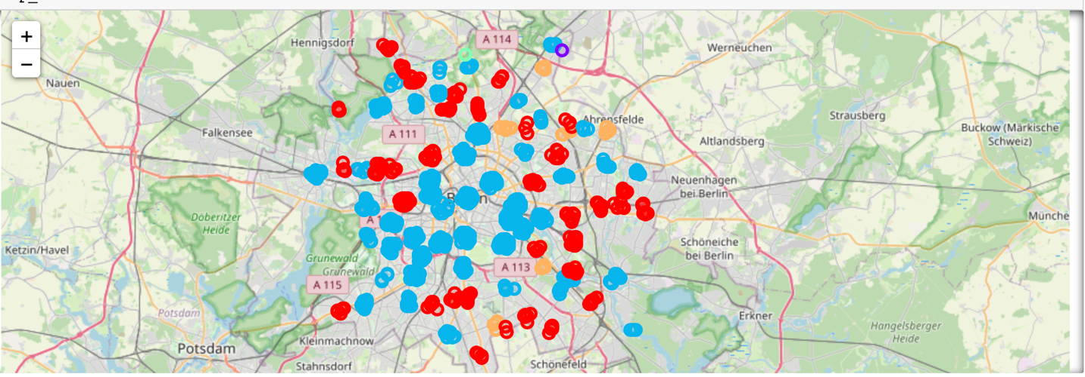

**Figure 4‑8 - Map of clustered neighbourhoods of Berlin**

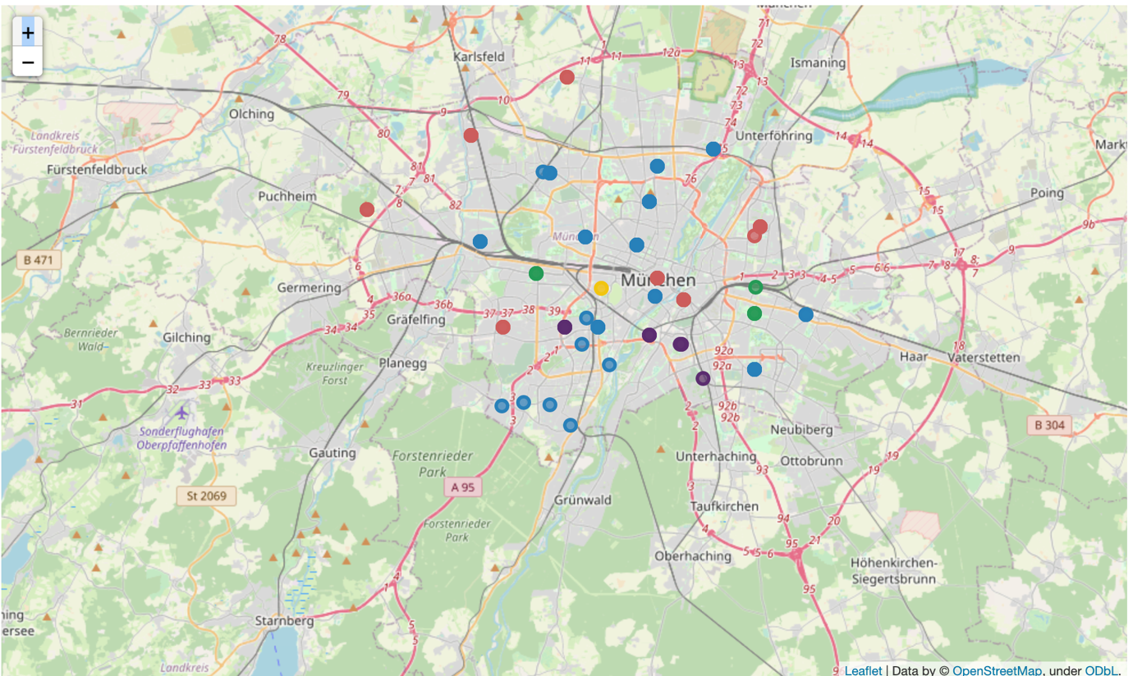

**Figure 4‑9 -Map of Clustered neighbourhood of Munich**

## Examining Clusters

We could examine our clusters by expanding on our code using the *Cluster Labels column*:

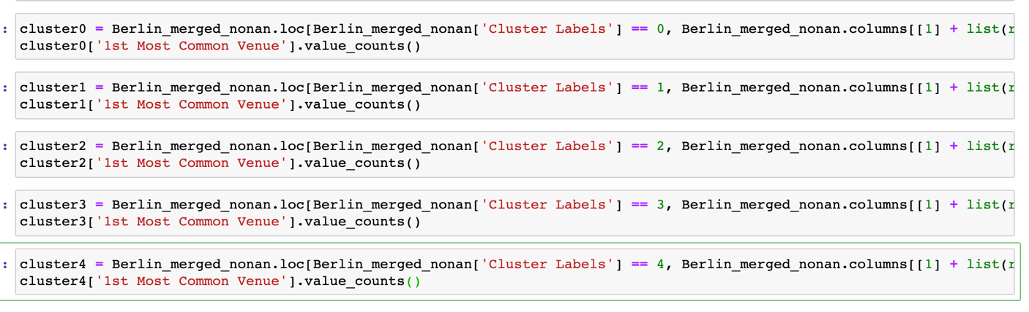

# Result and Discussion

The neighbourhoods of Berlin are very multicultural. Berlin seems to take a step further in this direction by having a lot of ssupermarkets, rrestaurants, bars, coffee shops, ice cream shops, drug store and cclothing store. It has a lot of shopping options too with that of the fish markets, ggarden center, gaming café, dessert shop, bookstores and sporting goods shop. The main modes of transport seem to be trams and buses. For leisure, the neighbourhoods are set up to have lots of parks, zoos, operas, and historic sites. After a further exploration of the clusters, each cluster can get a most common venue. Therefore, the clusters can be named by its most common venue.

In our case, in the cluster number zero the most common venues are Supermarket and Bakery. It has the greatest number of tram stations, metro stations and bus stops. This cluster also has café, soccer ffields, climbing gym and German restaurantss. This cloud especially fit to families having kids. The cluster number three has only one shop. In the last cluster, the most common venue is supermarket.

Overall, the city of Berlin offers a multicultural, diverse and certainly an entertaining experience.

Munich is only one third the size of Berlin in terms of city area. It has a wide variety of cuisines and eateries including Italian, Currywurst joint, Asian, Chinese etc. There are a lot of hangout spots including many Restaurants and Bars. Munich has a lot of Sporting goods shop. As one can see, the blue cluster is the most common cluster in Munich and therefore Munich seems to have a lot of similar districts in the city. In our case, the cluster number zero has most Sporting goods shop. In cluster number one, drugstores and supermarkets are the most common venues and it's therefore the Drugstore+Supermarket Cluster. The cluster number two has a lot of hotels and plazas. This cluster is my favourite, since it has a lot of coffee shops. In the the cluster number three, the most common venues are Afghan restaurants. And the last cluster is smallest cluster and it has one restaurant.

# Conclusion

The purpose of this project was to explore the cities of Berlin and Munich and see how attractive it is to potential migrants and tourists. We explored both the cities based on their postal codes and then extrapolated the common venues present in each of the neighbourhoods finally concluding with clustering similar neighbourhoods together.

We could see that each of the neighbourhoods in both the cities have a wide variety of experiences to offer which is unique in its own way. The cultural diversity is quite evident which also gives the feeling of a sense of inclusion.

Both Berlin and Munich seem to offer a romantic gateway with a lot of places to explore, beautiful landscapes and a wide variety of culture. Overall, it's up to the stakeholders to decide which experience they would prefer more, and which would suit their tastes better.

# References:

1. Munich Neighbourhood clustering using the K – means Algorithm

<https://medium.com/@brus.patrick63/munich-neighborhood-clustering-using-k-means-cde98a6e3199?sk=d55c0f9773160e217f3da572bb594c60>

1. IBM Capstone Project — The Battle of Neighbourhoods in Berlin: Restaurants

<https://medium.com/@lyan.fu.fly/ibm-capstone-project-the-battle-of-neighborhoods-in-berlin-restaurants-dd326f1bfacb>

1. A Tale of Two Cities: Clustering Neighbourhoods of London and Paris using Machine Learning

<https://medium.com/analytics-vidhya/a-tale-of-two-cities-clustering-neighborhoods-of-london-and-paris-5328f69cd8b6>

1. [Foursquare API](https://foursquare.com/)